#
# https://sd.tcsbank.ru/0/NUI/ViewModule.aspx#CardModuleV2/CasePage/edit/6dbbbea2-374c-4006-bb61-6c56935cc016
# SD#1965576
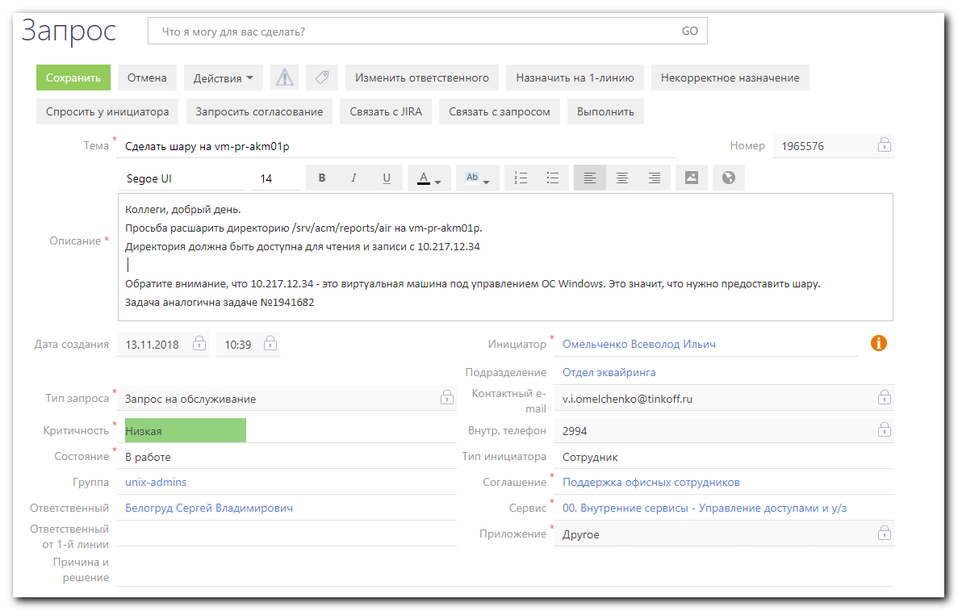

[s.belogrud@TCS4357]# ssh bsv@vm-pr-akm01p
Last login: Tue Aug 28 12:23:42 2018 from 172.16.28.74
[bsv@vm-pr-akm01p ~]$ sudo -i
[sudo] password for bsv:
[root@vm-pr-akm01p ~]# cat /etc/redhat-release
Red Hat Enterprise Linux Server release 7.3 (Maipo)
[root@vm-pr-akm01p ~]# systemctl status firewalld.service
● firewalld.service - firewalld - dynamic firewall daemon
Loaded: loaded (/usr/lib/systemd/system/firewalld.service; disabled; vendor preset: enabled)
Active: inactive (dead)
Docs: man:firewalld(1)
[root@vm-pr-akm01p ~]# getenforce
Permissive
[root@vm-pr-akm01p ~]#

[root@vm-pr-akm01p ~]# yum install samba

[root@vm-pr-akm01p ~]# yum history info 18
Loaded plugins: etckeeper, product-id, search-disabled-repos, subscription-manager
This system is not registered to Red Hat Subscription Management. You can use subscription-manager to register.
Transaction ID : 18
Begin time : Tue Nov 20 11:32:17 2018
Begin rpmdb : 485:536663d0b355e04459b42854aa6f75e4ea80a75f
End time : 11:32:23 2018 (6 seconds)
End rpmdb : 497:15fb794de7d8ba22d2211c66bab37872e5796582
User : Belogrud Sergey Vladimirovich,BC Diapazone,2173 <bsv>
Return-Code : Success
Command Line : install samba
Transaction performed with:
Installed rpm-4.11.3-21.el7.x86_64 @anaconda/7.3
Installed subscription-manager-1.17.15-1.el7.x86_64 @anaconda/7.3
Installed yum-3.4.3-150.el7.noarch @anaconda/7.3
Installed yum-metadata-parser-1.1.4-10.el7.x86_64 @anaconda/7.3
Packages Altered:
Dep-Install libldb-1.3.4-1.el7.x86_64 @rhel-7-server-rpms
Dep-Install libtalloc-2.1.13-1.el7.x86_64 @rhel-7-server-rpms
Dep-Install libtdb-1.3.15-1.el7.x86_64 @rhel-7-server-rpms
Dep-Install libtevent-0.9.36-1.el7.x86_64 @rhel-7-server-rpms
Dep-Install libwbclient-4.8.3-4.el7.x86_64 @rhel-7-server-rpms
Dep-Install pytalloc-2.1.13-1.el7.x86_64 @rhel-7-server-rpms
Install samba-4.8.3-4.el7.x86_64 @rhel-7-server-rpms
Dep-Install samba-client-libs-4.8.3-4.el7.x86_64 @rhel-7-server-rpms
Dep-Install samba-common-4.8.3-4.el7.noarch @rhel-7-server-rpms
Dep-Install samba-common-libs-4.8.3-4.el7.x86_64 @rhel-7-server-rpms
Dep-Install samba-common-tools-4.8.3-4.el7.x86_64 @rhel-7-server-rpms
Dep-Install samba-libs-4.8.3-4.el7.x86_64 @rhel-7-server-rpms
history info
[root@vm-pr-akm01p ~]#

[root@vm-pr-akm01p ~]# ls -Alhd /srv/acm/reports/air
drwxrwsr-x. 3 v.i.omelchenko root 18 Nov 8 13:13 /srv/acm/reports/air
[root@vm-pr-akm01p ~]#

[root@vm-pr-akm01p ~]# vim /etc/samba/smb.conf
[root@vm-pr-akm01p ~]# tail -n 16 /etc/samba/smb.conf

[global]
security = user
workgroup = MYGROUP
server string = Samba
guest account = nobody
map to guest = Bad Password

[storage]
path = /srv/acm/reports/air
browsable = yes
writable = yes
guest ok = yes
read only = no
hosts allow = 10.217.12.34

[root@vm-pr-akm01p ~]#

[root@vm-pr-akm01p ~]# chmod o+w /srv/acm/reports/air
[root@vm-pr-akm01p ~]# ls -Alhd /srv/acm/reports/air
drwxrwsrwx. 3 v.i.omelchenko root 18 Nov 8 13:13 /srv/acm/reports/air
[root@vm-pr-akm01p ~]# stat /srv/acm/reports/air
File: ‘/srv/acm/reports/air’
Size: 18 Blocks: 0 IO Block: 4096 directory
Device: fd00h/64768d Inode: 6001956 Links: 3
Access: (2777/drwxrwsrwx) Uid: ( 4077/v.i.omelchenko) Gid: ( 0/ root)
Context: unconfined_u:object_r:var_t:s0
Access: 2018-11-19 14:00:00.005845628 +0300
Modify: 2018-11-08 13:13:20.503707849 +0300
Change: 2018-11-20 11:38:54.390767737 +0300
Birth: -
[root@vm-pr-akm01p ~]#

[root@vm-pr-akm01p ~]# namei -l /srv/acm/reports/air
f: /srv/acm/reports/air
dr-xr-xr-x root root /
drwxr-xr-x root root srv
drwxrwsrwt root root acm
drwxrwsr-x v.i.omelchenko root reports
drwxrwsrwx v.i.omelchenko root air
[root@vm-pr-akm01p ~]#

[root@vm-pr-akm01p ~]# systemctl status smb.service
● smb.service - Samba SMB Daemon
Loaded: loaded (/usr/lib/systemd/system/smb.service; disabled; vendor preset: disabled)
Active: inactive (dead)
Docs: man:smbd(8)
man:samba(7)
man:smb.conf(5)
[root@vm-pr-akm01p ~]# systemctl start smb.service
[root@vm-pr-akm01p ~]# systemctl status smb.service
● smb.service - Samba SMB Daemon
Loaded: loaded (/usr/lib/systemd/system/smb.service; disabled; vendor preset: disabled)
Active: active (running) since Tue 2018-11-20 11:40:02 MSK; 3s ago
Docs: man:smbd(8)
man:samba(7)
man:smb.conf(5)
Main PID: 5492 (smbd)
Status: "smbd: ready to serve connections..."
CGroup: /system.slice/smb.service
├─5492 /usr/sbin/smbd --foreground --no-process-group
├─5494 /usr/sbin/smbd --foreground --no-process-group
├─5495 /usr/sbin/smbd --foreground --no-process-group
└─5496 /usr/sbin/smbd --foreground --no-process-group

Nov 20 11:40:01 vm-pr-akm01p.tcsbank.ru systemd[1]: Starting Samba SMB Daemon...
Nov 20 11:40:02 vm-pr-akm01p.tcsbank.ru smbd[5492]: [2018/11/20 11:40:02.103887, 0] ../lib/util/become_daemon.c:138(daemon_ready)
Nov 20 11:40:02 vm-pr-akm01p.tcsbank.ru systemd[1]: Started Samba SMB Daemon.
Nov 20 11:40:02 vm-pr-akm01p.tcsbank.ru smbd[5492]: daemon_ready: STATUS=daemon 'smbd' finished starting up and ready to serve connections
[root@vm-pr-akm01p ~]# systemctl enable smb.service
Created symlink from /etc/systemd/system/multi-user.target.wants/smb.service to /usr/lib/systemd/system/smb.service.
[root@vm-pr-akm01p ~]# systemctl status smb.service
● smb.service - Samba SMB Daemon
Loaded: loaded (/usr/lib/systemd/system/smb.service; enabled; vendor preset: disabled)
Active: active (running) since Tue 2018-11-20 11:40:02 MSK; 25s ago
Docs: man:smbd(8)
man:samba(7)
man:smb.conf(5)
Main PID: 5492 (smbd)
Status: "smbd: ready to serve connections..."
CGroup: /system.slice/smb.service
├─5492 /usr/sbin/smbd --foreground --no-process-group
├─5494 /usr/sbin/smbd --foreground --no-process-group
├─5495 /usr/sbin/smbd --foreground --no-process-group
└─5496 /usr/sbin/smbd --foreground --no-process-group

Nov 20 11:40:01 vm-pr-akm01p.tcsbank.ru systemd[1]: Starting Samba SMB Daemon...
Nov 20 11:40:02 vm-pr-akm01p.tcsbank.ru smbd[5492]: [2018/11/20 11:40:02.103887, 0] ../lib/util/become_daemon.c:138(daemon_ready)
Nov 20 11:40:02 vm-pr-akm01p.tcsbank.ru systemd[1]: Started Samba SMB Daemon.
Nov 20 11:40:02 vm-pr-akm01p.tcsbank.ru smbd[5492]: daemon_ready: STATUS=daemon 'smbd' finished starting up and ready to serve connections
[root@vm-pr-akm01p ~]#

[root@vm-pr-akm01p ~]# smbstatus

Samba version 4.8.3
PID Username Group Machine Protocol Version Encryption Signing
----------------------------------------------------------------------------------------------------------------------------------------

Service pid Machine Connected at Encryption Signing
---------------------------------------------------------------------------------------------

No locked files

[root@vm-pr-akm01p ~]# testparm
Load smb config files from /etc/samba/smb.conf
rlimit_max: increasing rlimit_max (1024) to minimum Windows limit (16384)
Processing section "[storage]"
Loaded services file OK.
Server role: ROLE_STANDALONE

Press enter to see a dump of your service definitions

# Global parameters
[global]
map to guest = Bad Password
security = USER
server string = Samba
workgroup = MYGROUP
idmap config * : backend = tdb

[storage]
guest ok = Yes
hosts allow = 10.217.12.34
path = /srv/acm/reports/air
read only = No
[root@vm-pr-akm01p ~]#

[root@vm-pr-akm01p ~]# systemctl status winbind.service
Unit winbind.service could not be found.
[root@vm-pr-akm01p ~]# ps faux | grep sm[b]
root 5492 0.1 0.1 411760 11376 ? Ss 11:40 0:00 /usr/sbin/smbd --foreground --no-process-group
root 5494 0.0 0.0 406408 2944 ? S 11:40 0:00 \_ /usr/sbin/smbd --foreground --no-process-group
root 5495 0.0 0.0 406400 2636 ? S 11:40 0:00 \_ /usr/sbin/smbd --foreground --no-process-group
root 5496 0.0 0.0 411760 3224 ? S 11:40 0:00 \_ /usr/sbin/smbd --foreground --no-process-group
[root@vm-pr-akm01p ~]#

[root@vm-pr-akm01p ~]# ip -f inet addr | grep inet
inet 127.0.0.1/8 scope host lo
inet 10.217.12.84/24 brd 10.217.12.255 scope global eth0
[root@vm-pr-akm01p ~]# host 10.217.12.34
34.12.217.10.in-addr.arpa domain name pointer vm-pr-nspk01p.tcsbank.ru.
[root@vm-pr-akm01p ~]#

[root@vm-pr-akm01p ~]# ls -Alh /var/log/samba/
total 4.0K
drwx------. 3 root root 18 Nov 20 11:40 cores
-rw-r--r--. 1 root root 168 Nov 20 11:40 log.smbd
drwx------. 2 root root 6 Aug 9 16:55 old
[root@vm-pr-akm01p ~]#

[root@vm-pr-akm01p ~]# grep -ie "smb" /var/log/messages
Nov 20 11:40:01 vm-pr-akm01p systemd: Starting Samba SMB Daemon...
Nov 20 11:40:02 vm-pr-akm01p smbd[5492]: [2018/11/20 11:40:02.103887, 0] ../lib/util/become_daemon.c:138(daemon_ready)
Nov 20 11:40:02 vm-pr-akm01p systemd: Started Samba SMB Daemon.
Nov 20 11:40:02 vm-pr-akm01p smbd[5492]: daemon_ready: STATUS=daemon 'smbd' finished starting up and ready to serve connections
[root@vm-pr-akm01p ~]#

#
# I’ve forgotten to change name of shared resource.
#
[root@vm-pr-akm01p ~]# vim /etc/samba/smb.conf
[root@vm-pr-akm01p ~]# tail -n 16 /etc/samba/smb.conf

[global]
security = user
workgroup = MYGROUP
server string = Samba
guest account = nobody
map to guest = Bad Password

[srv_acm_reports_air]
path = /srv/acm/reports/air
browsable = yes
writable = yes
guest ok = yes
read only = no
hosts allow = 10.217.12.34

[root@vm-pr-akm01p ~]#

[root@vm-pr-akm01p ~]# systemctl reload smb.service
[root@vm-pr-akm01p ~]#

Я установил, настроил, запустил ПО samba на сервере vm-pr-akm01p.
Попробуйте подключиться с хоста 10.217.12.34 (vm-pr-nspk01p.tcsbank.ru) к серверу vm-pr-akm01p - открыть в проводнике MS Windows адрес \\vm-pr-akm01p\srv_acm_reports_air

[root@vm-pr-akm01p ~]# smbstatus

Samba version 4.8.3
PID Username Group Machine Protocol Version Encryption Signing
----------------------------------------------------------------------------------------------------------------------------------------
6579 nobody nobody 10.217.12.34 (ipv4:10.217.12.34:53729) SMB2_10 - -

Service pid Machine Connected at Encryption Signing
---------------------------------------------------------------------------------------------
srv_acm_reports_air 6579 10.217.12.34 Tue Nov 20 11:57:56 AM 2018 MSK - -

Locked files:
Pid Uid DenyMode Access R/W Oplock SharePath Name Time
--------------------------------------------------------------------------------------------------
6579 99 DENY_NONE 0x100080 RDONLY NONE /srv/acm/reports/air . Tue Nov 20 11:59:17 2018
6579 99 DENY_NONE 0x100081 RDONLY NONE /srv/acm/reports/air . Tue Nov 20 11:59:21 2018

[root@vm-pr-akm01p ~]#

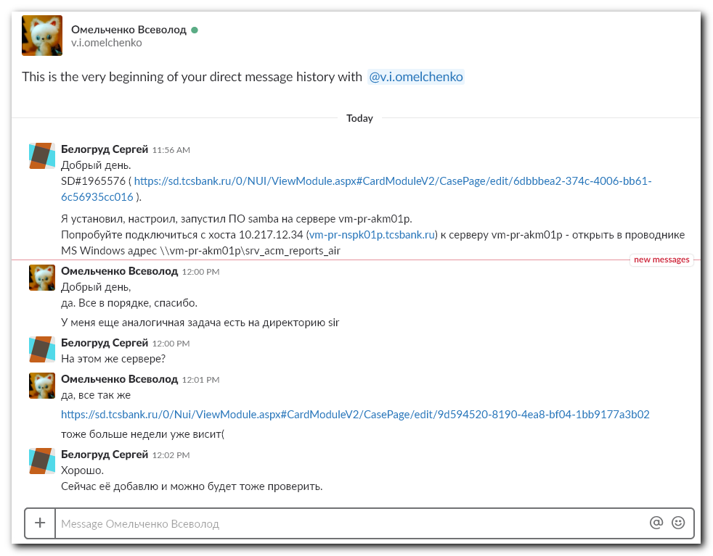

#
# SD#1941682
# https://sd.tcsbank.ru/0/Nui/ViewModule.aspx#CardModuleV2/CasePage/edit/9d594520-8190-4ea8-bf04-1bb9177a3b02
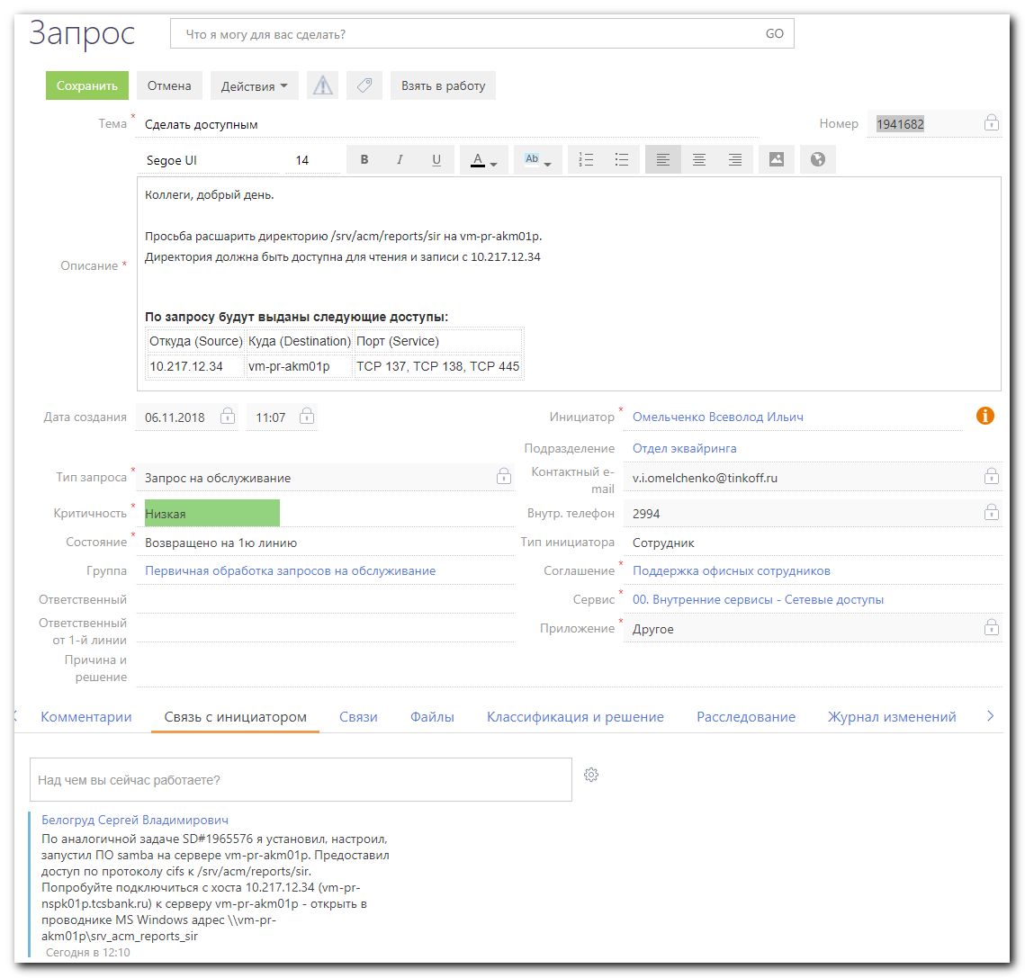

[root@vm-pr-akm01p ~]# ls -Alhd /srv/acm/reports/sir
drwxrwsr-x. 3 v.i.omelchenko root 18 Nov 19 15:01 /srv/acm/reports/sir
[root@vm-pr-akm01p ~]# chmod o+w /srv/acm/reports/sir
[root@vm-pr-akm01p ~]# ls -Alhd /srv/acm/reports/sir
drwxrwsrwx. 3 v.i.omelchenko root 18 Nov 19 15:01 /srv/acm/reports/sir
[root@vm-pr-akm01p ~]# stat /srv/acm/reports/sir
File: ‘/srv/acm/reports/sir’
Size: 18 Blocks: 0 IO Block: 4096 directory
Device: fd00h/64768d Inode: 50679687 Links: 3
Access: (2777/drwxrwsrwx) Uid: ( 4077/v.i.omelchenko) Gid: ( 0/ root)
Context: unconfined_u:object_r:var_t:s0
Access: 2018-11-19 15:30:00.001258347 +0300
Modify: 2018-11-19 15:01:09.882485077 +0300
Change: 2018-11-20 12:04:34.747725593 +0300
Birth: -
[root@vm-pr-akm01p ~]# namei -l /srv/acm/reports/sir
f: /srv/acm/reports/sir
dr-xr-xr-x root root /
drwxr-xr-x root root srv
drwxrwsrwt root root acm
drwxrwsr-x v.i.omelchenko root reports
drwxrwsrwx v.i.omelchenko root sir
[root@vm-pr-akm01p ~]#

[root@vm-pr-akm01p ~]# vim /etc/samba/smb.conf
[root@vm-pr-akm01p ~]#
[root@vm-pr-akm01p ~]# tail -n 24 /etc/samba/smb.conf

[global]
security = user
workgroup = MYGROUP
server string = Samba
guest account = nobody
map to guest = Bad Password

[srv_acm_reports_air]
path = /srv/acm/reports/air
browsable = yes
writable = yes
guest ok = yes
read only = no
hosts allow = 10.217.12.34

[srv_acm_reports_sir]
path = /srv/acm/reports/sir
browsable = yes
writable = yes
guest ok = yes
read only = no
hosts allow = 10.217.12.34

[root@vm-pr-akm01p ~]#

[root@vm-pr-akm01p ~]# systemctl reload smb.service

[root@vm-pr-akm01p ~]# grep -ie "smb" /var/log/messages
Nov 20 11:40:01 vm-pr-akm01p systemd: Starting Samba SMB Daemon...
Nov 20 11:40:02 vm-pr-akm01p smbd[5492]: [2018/11/20 11:40:02.103887, 0] ../lib/util/become_daemon.c:138(daemon_ready)
Nov 20 11:40:02 vm-pr-akm01p systemd: Started Samba SMB Daemon.
Nov 20 11:40:02 vm-pr-akm01p smbd[5492]: daemon_ready: STATUS=daemon 'smbd' finished starting up and ready to serve connections
Nov 20 11:52:59 vm-pr-akm01p systemd: Reloaded Samba SMB Daemon.
Nov 20 12:06:53 vm-pr-akm01p systemd: Reloaded Samba SMB Daemon.
[root@vm-pr-akm01p ~]#

По аналогичной задаче SD#1965576 я установил, настроил, запустил ПО samba на сервере vm-pr-akm01p. Предоставил доступ по протоколу cifs к /srv/acm/reports/sir.
Попробуйте подключиться с хоста 10.217.12.34 (vm-pr-nspk01p.tcsbank.ru) к серверу vm-pr-akm01p - открыть в проводнике MS Windows адрес \\vm-pr-akm01p\srv_acm_reports_sir

[root@vm-pr-akm01p ~]# smbstatus

Samba version 4.8.3
PID Username Group Machine Protocol Version Encryption Signing
----------------------------------------------------------------------------------------------------------------------------------------
10909 nobody nobody 10.217.12.34 (ipv4:10.217.12.34:53877) SMB2_10 - -

Service pid Machine Connected at Encryption Signing
---------------------------------------------------------------------------------------------
srv_acm_reports_sir 10909 10.217.12.34 Tue Nov 20 12:46:39 PM 2018 MSK - -

Locked files:
Pid Uid DenyMode Access R/W Oplock SharePath Name Time
--------------------------------------------------------------------------------------------------
10909 99 DENY_NONE 0x100080 RDONLY NONE /srv/acm/reports/sir . Tue Nov 20 12:46:40 2018
10909 99 DENY_NONE 0x100081 RDONLY NONE /srv/acm/reports/sir . Tue Nov 20 12:46:43 2018

[root@vm-pr-akm01p ~]#

